Digital Design Diploma

# **Assignment 3**

# **Sequential Logic Design**

|  |  |
| --- | --- |
| **Name** | كريم حسن عاطف علي |
| **Group** | G2 |

**Submitted to: Eng. Kareem Waseem**

1. **DFF with clock enable and PRE control signal:**

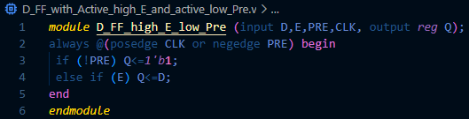

Figure1: Q1 Code

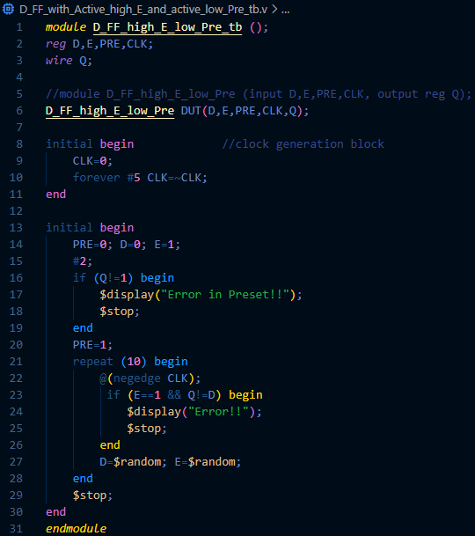

Figure 2: Q1 Testbench

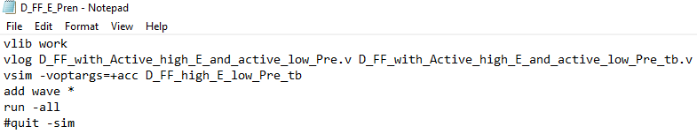

Figure 3: Q1 DO File

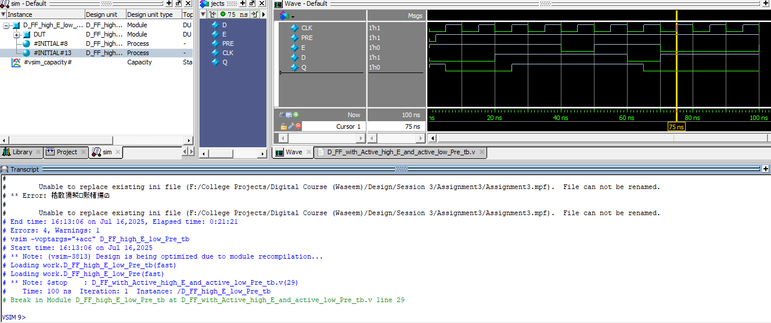

Figure 4: Q1 Wave

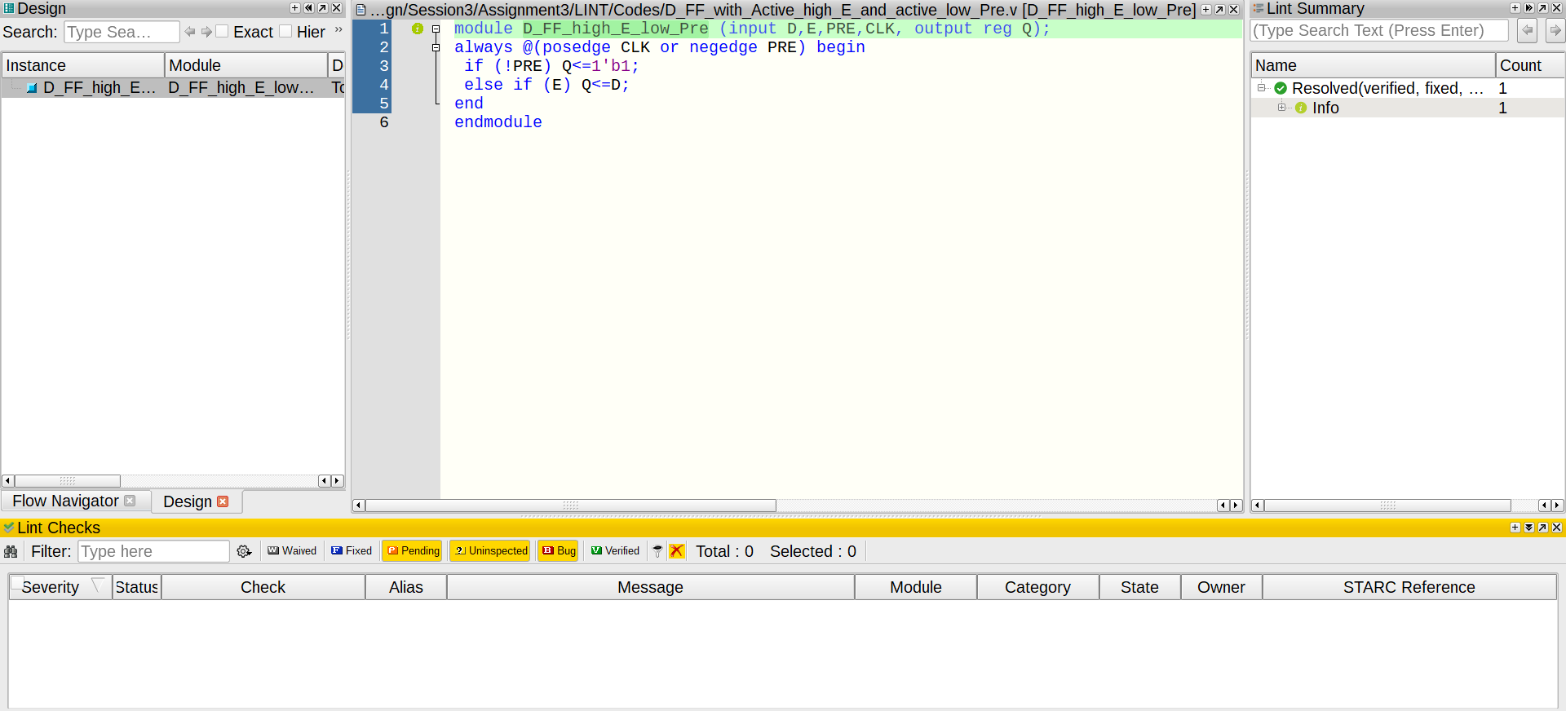

Figure 5: Q1 Linting

1. **Parameterized Asynchronous FF with Active low rst (D FF & T FF):**

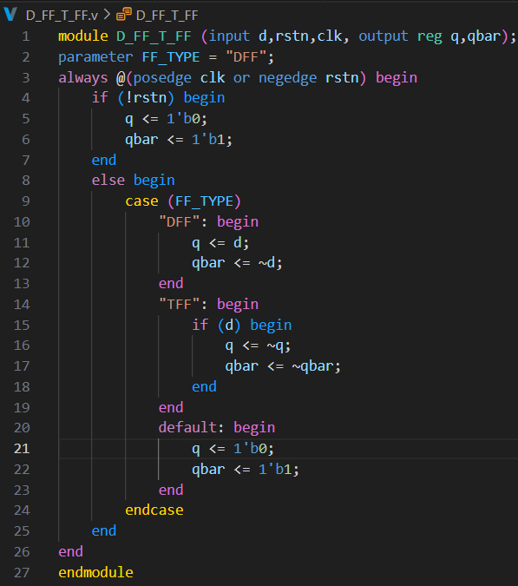

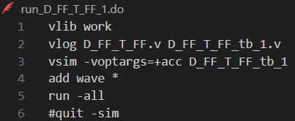

Figure 6: Q2 Code

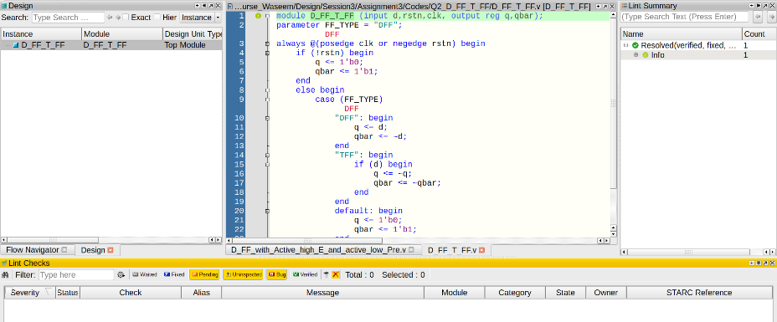

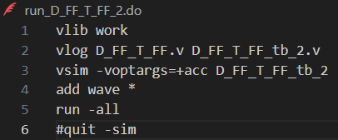

Figure 9: Q2 Linting

Figure 7: Q2 DO File (DFF)

Figure 8: Q2 DO File (TFF)

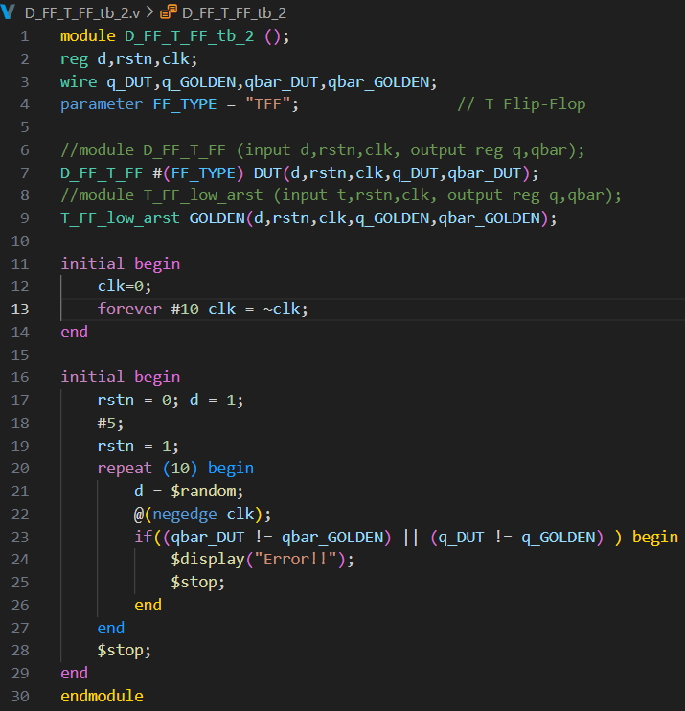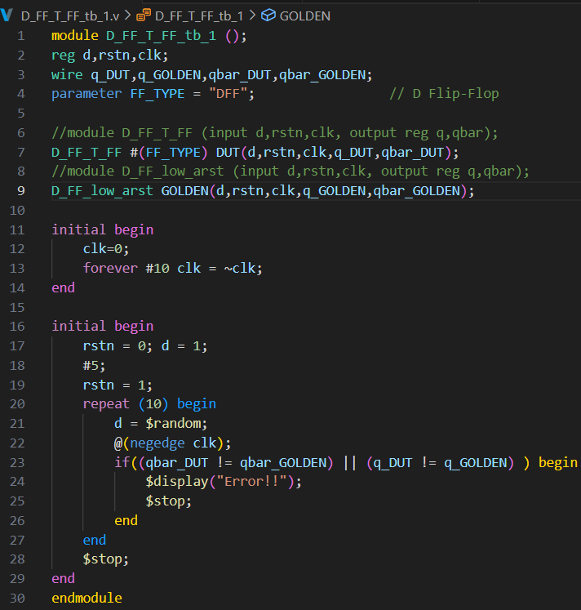

Figure 11: Q2 Testbench (TFF)

Figure 10: Q2 Testbench (DFF)

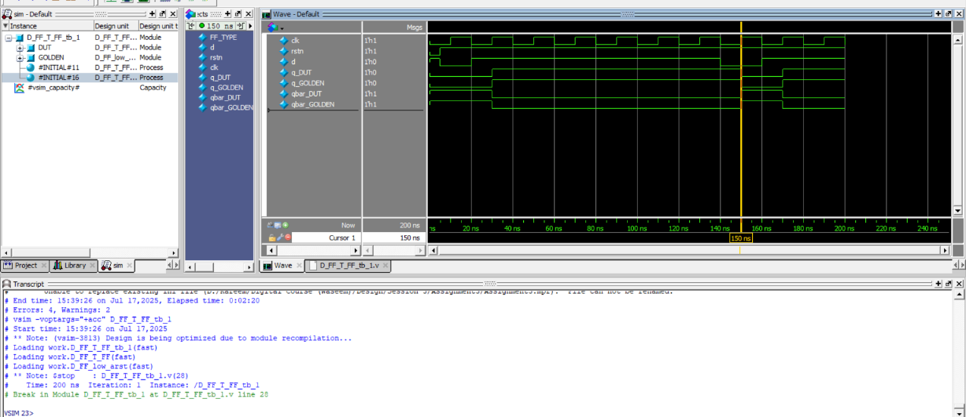

Figure 12: Q2 Wave (DFF)

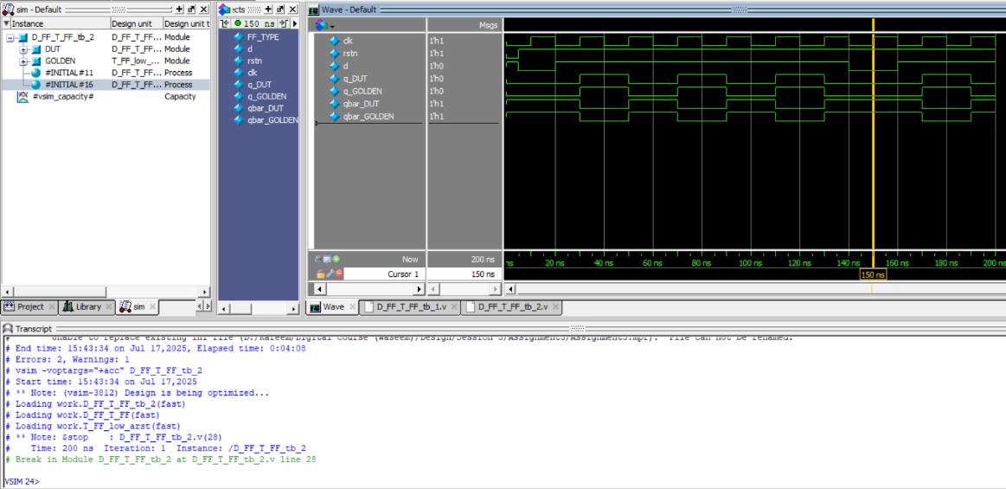

Figure 13: Q2 Wave (TFF)

1. **BCD up counter (MOD 10 counter):**

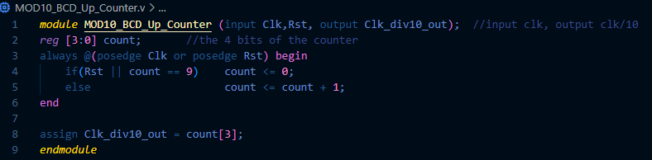

Figure 14: Q3 Code

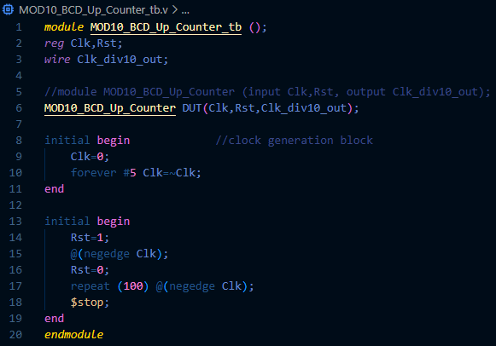

Figure 15: Q3 Testbench

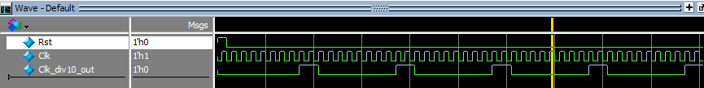

Figure 16: Q3 Wave

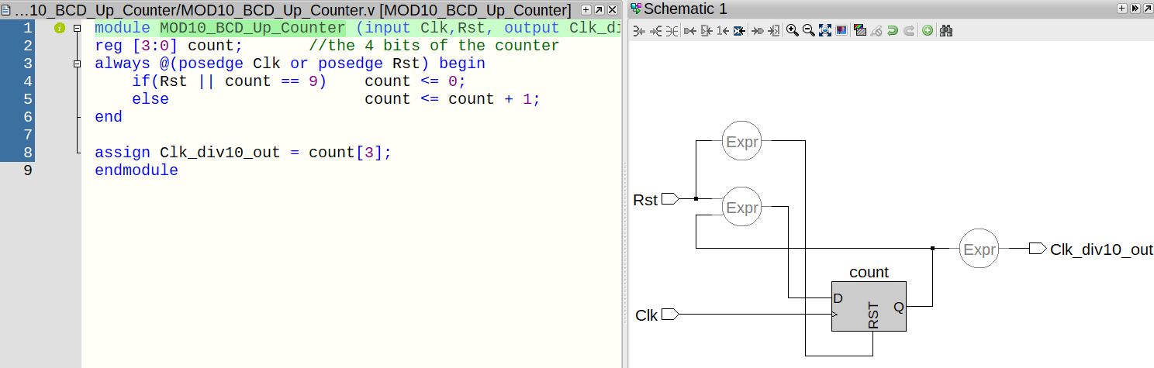

Figure 17: Q3 Linting

1. **4-bit Ripple Counter:**

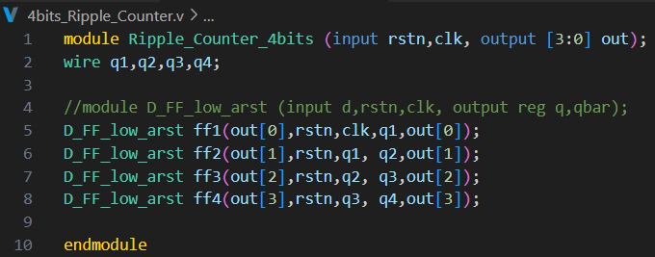

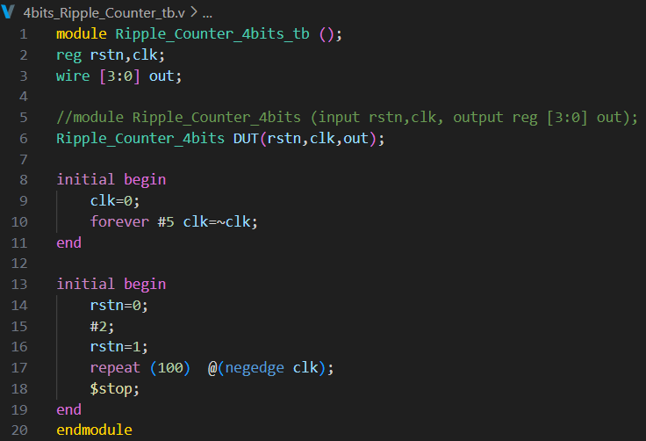

Figure 18: Q4 Code

Figure 19: Q4 Testbench

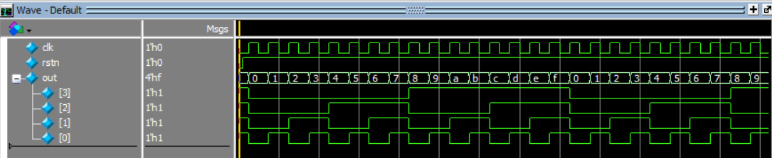

Figure 20: Q4 Wave

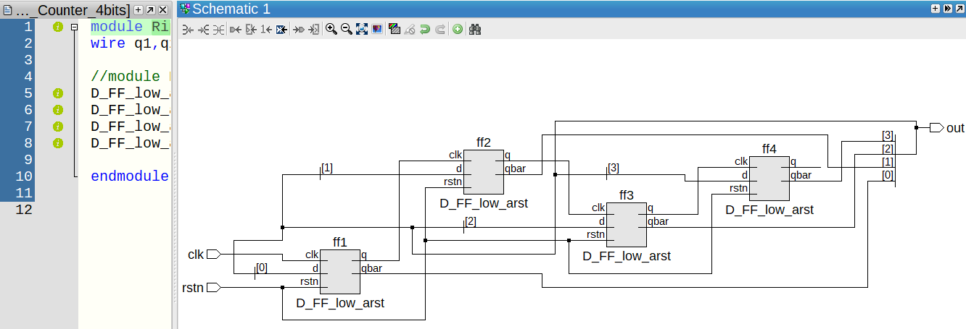

Figure 21: Q4 Linting

1. **Parameterized Shift register:**

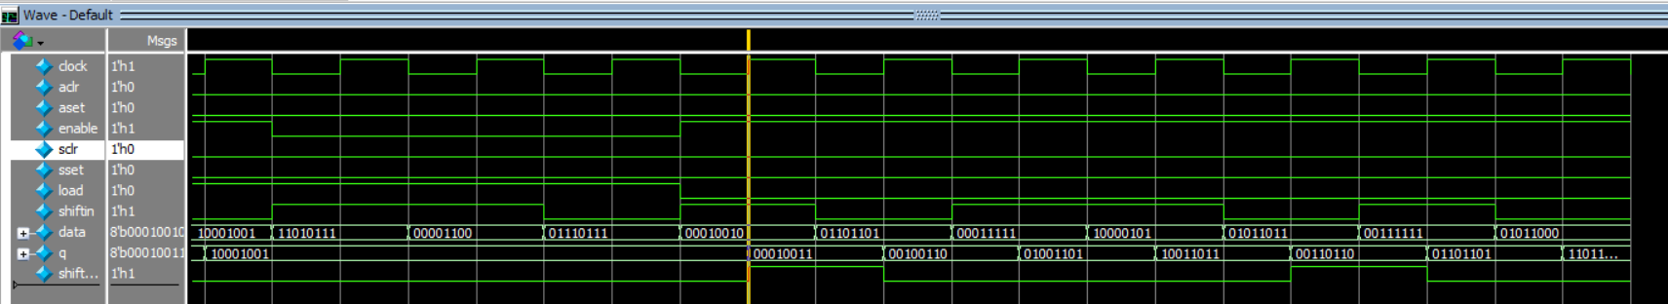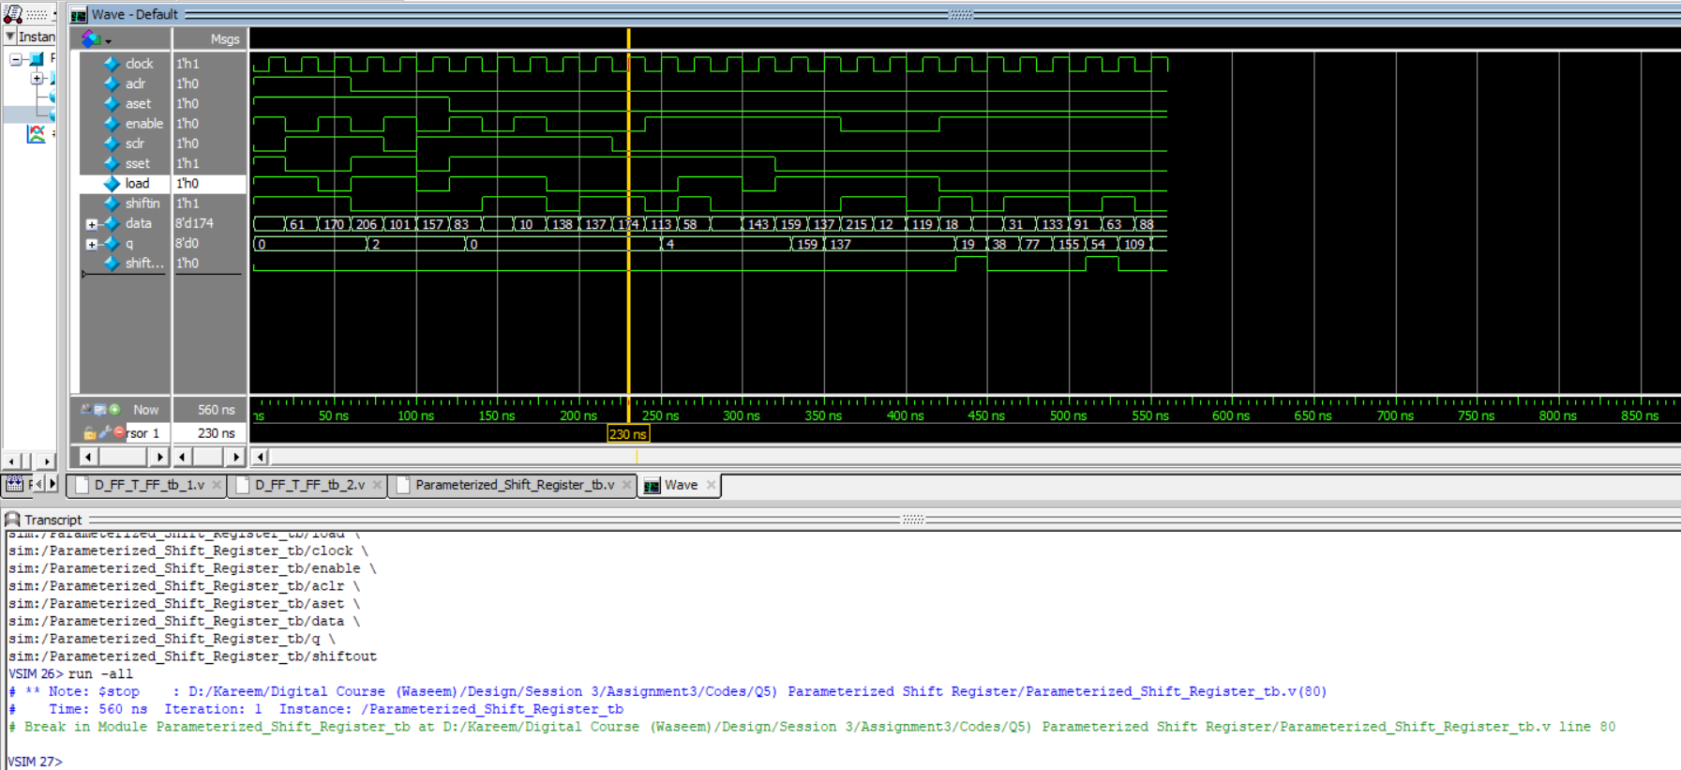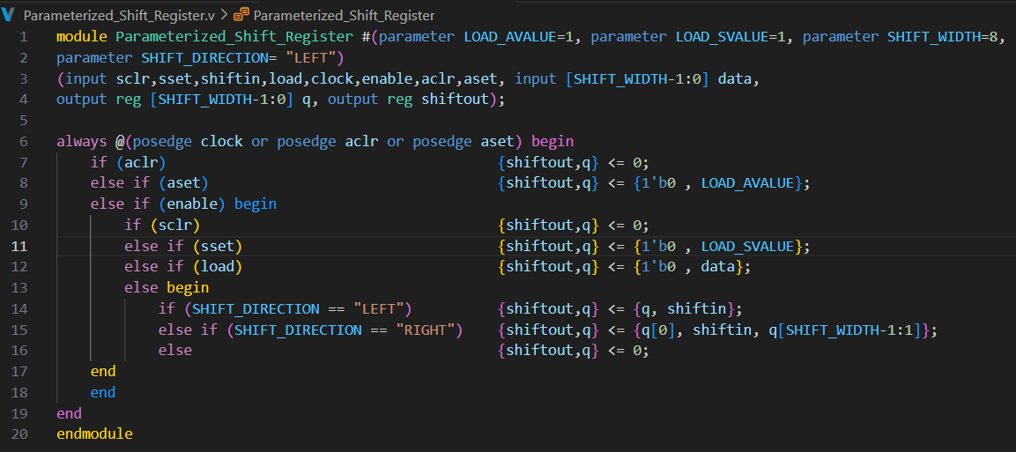

Figure 24: Q5 Wave (Shifting Part)

Figure 23: Q5 Wave

Figure 22: Q5 Code

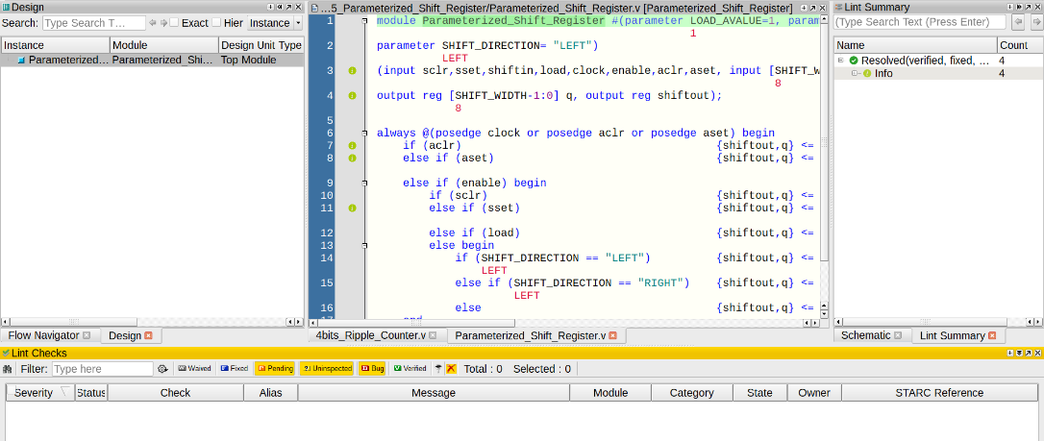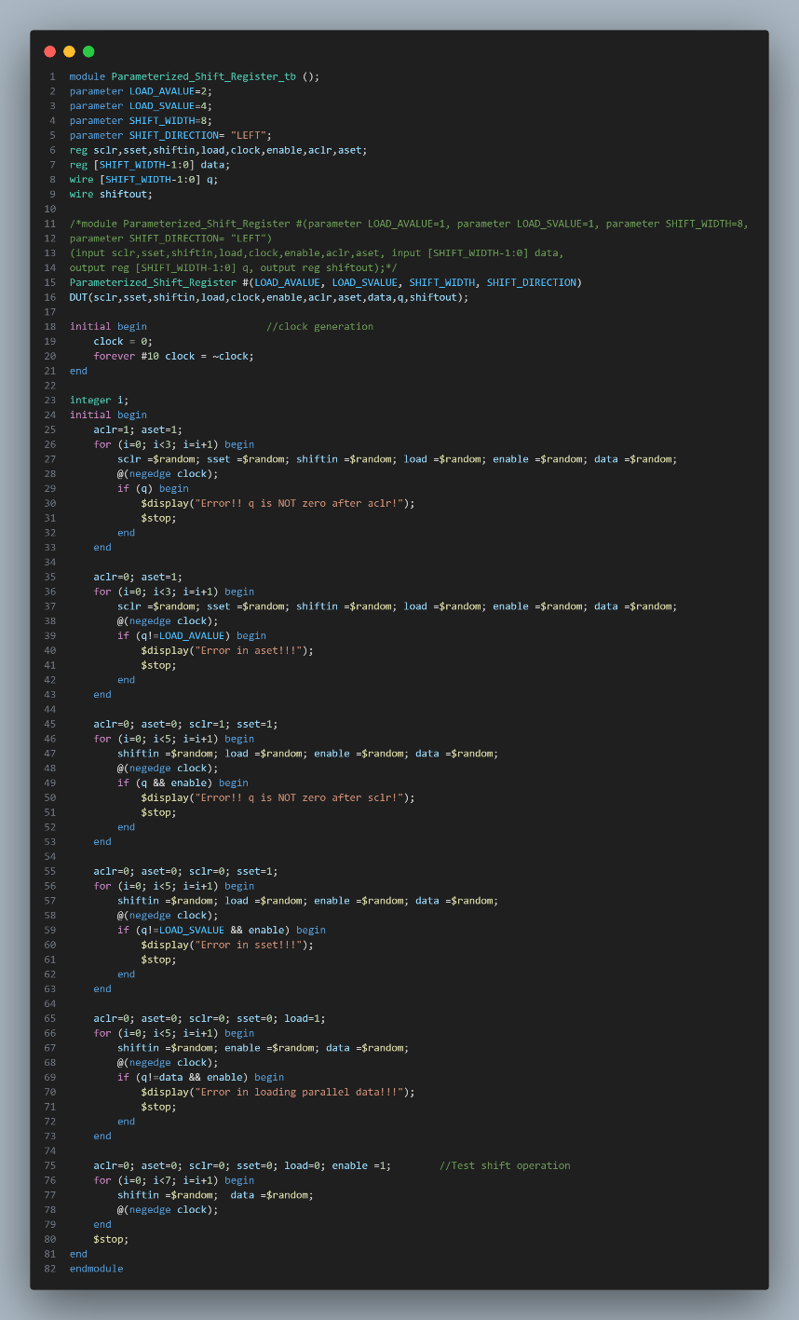

Figure 26: Q5 Linting

Figure 25: Q5 Testbench

1. **SLE (Sequential Logic Element):**

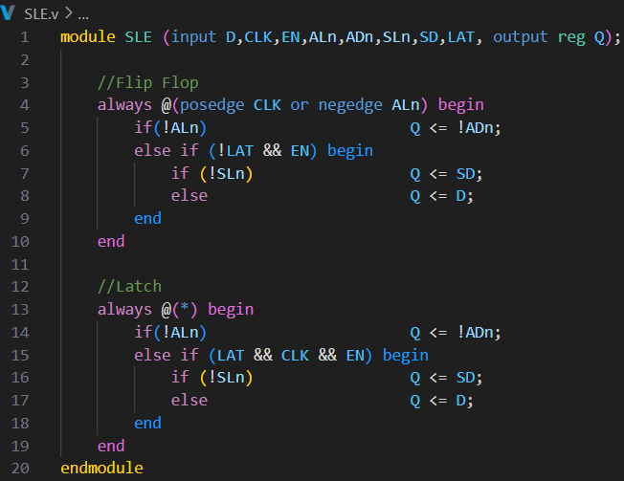

Figure 27: Q6 Code

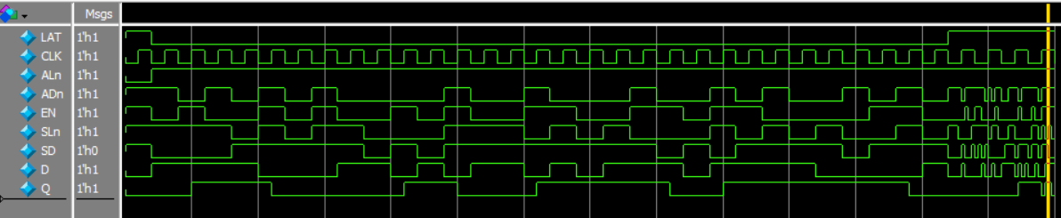

Figure 28: Q6 Wave

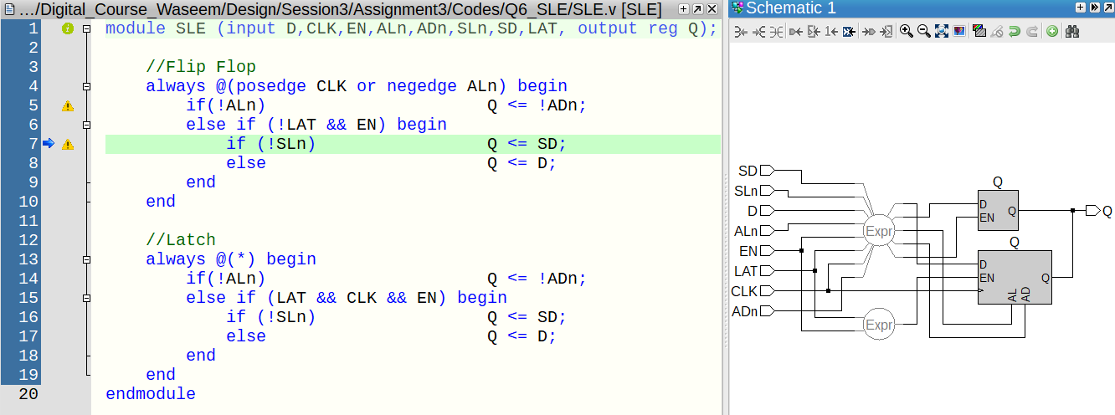

Figure 29: Q6 Linting

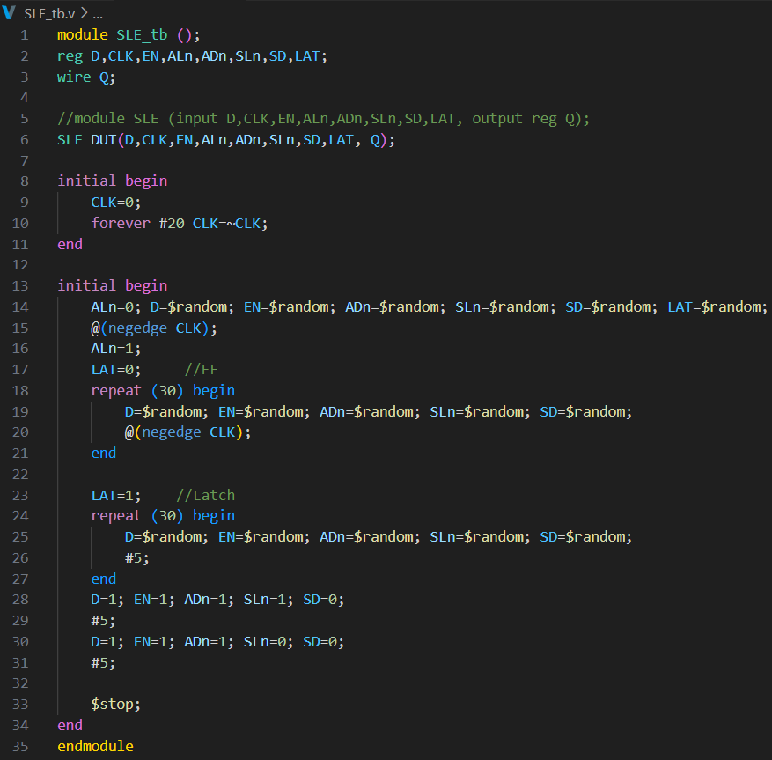

Figure 30: Q6 Testbench